Customer Shopping Behavior Analysis

1. Introduction and Problem Statement
Understanding how customers shop is essential for improving sales performance, customer satisfaction, and long-term business growth. This project focuses on analyzing customer purchase data to identify meaningful patterns related to spending behavior, product preferences, discounts, and subscriptions. The insights derived from this analysis can help businesses make informed decisions in marketing, pricing, and customer retention strategies.

2. Data Description
The dataset used in this project contains transactional records of customer purchases collected across multiple product categories.
Dataset Characteristics:
- Total Records: Approximately 3,900 transactions
- Total Attributes: 18 columns
Key Data Attributes:
- Customer Information: Age, gender, location, and subscription status
- Purchase Information: Product name, category, size, color, season, and purchase value
- Behavioral Indicators: Discount usage, previous purchase count, purchase frequency, product reviews, and shipping method
A small number of missing values were observed in the customer review ratings column, which were handled during data preprocessing.

3. Data Cleaning and Preparation (Python)
Python was used as the primary tool for cleaning and preparing the dataset for analysis.

3.1 Initial Data Exploration
- Loaded the dataset using the pandas library
- Reviewed data structure, column types, and summary statistics
- Identified missing and inconsistent values
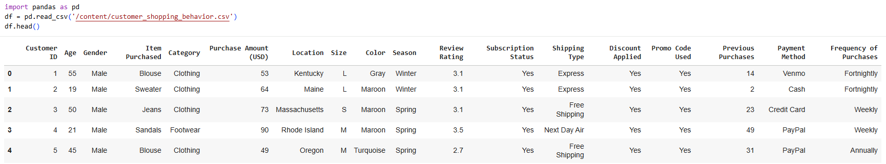
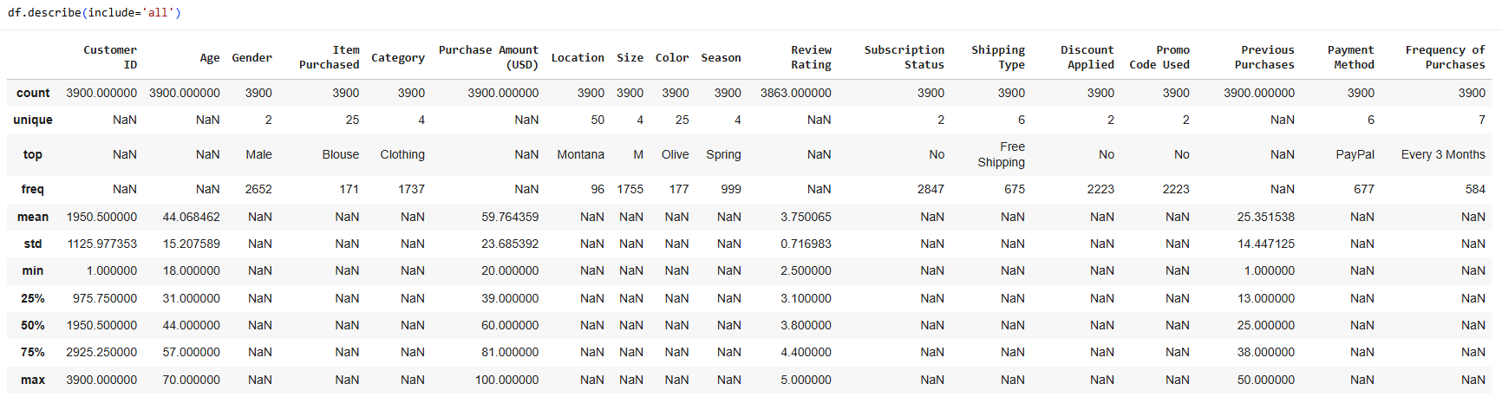

3.2 Handling Missing Values
- Missing values in the review rating column were treated using median-based imputation grouped by product category
- This approach helped preserve realistic rating distributions
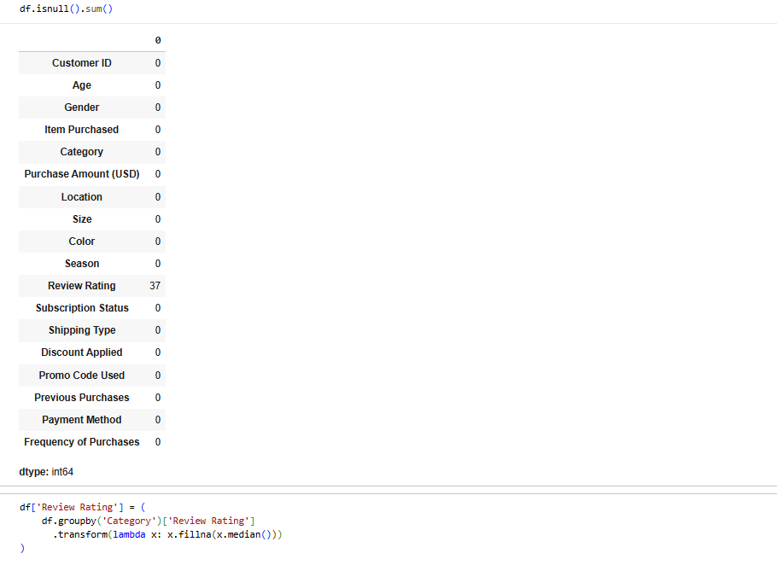

3.3 Data Standardization
- Column names were converted into snake_case format for better readability
- Data types were verified and corrected where necessary
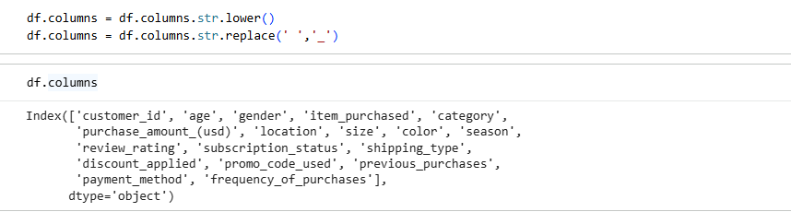

3.4 Feature Engineering
To enhance analytical depth, new features were created:
- Age Group: Customers were grouped into age brackets to simplify demographic analysis
- Purchase Frequency (Days): Purchase frequency labels were converted into numeric values representing time intervals

3.5 Data Optimization
- Redundant columns related to discount usage were evaluated
- One overlapping column was removed to reduce data duplication
After preprocessing, the cleaned dataset was exported and stored in a PostgreSQL database for structured analysis.

4. Business Analysis Using SQL
Structured Query Language (SQL) was used to answer important business questions from the cleaned data.

Key Analyses Performed:
- Revenue by Gender – Compared total revenue generated by male vs. female customers.
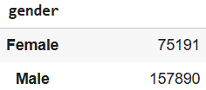
- High-Spending Discount Users – Identified customers who used discounts but still spent above the average purchase amount.
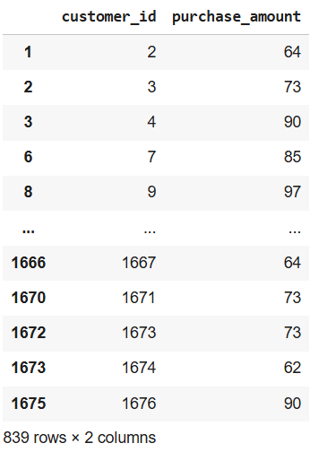
- Top 5 Products by Rating – Found products with the highest average review ratings.
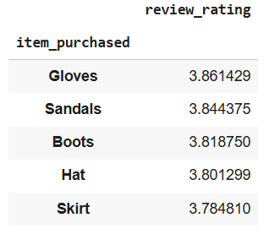
- Shipping Type Comparison – Compared average purchase amounts between Standard and Express shipping.
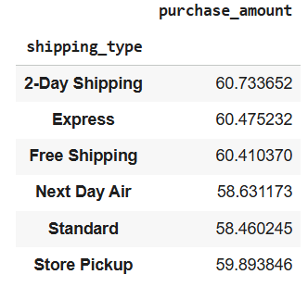

- Subscribers vs. Non-Subscribers – Compared average spend and total revenue across subscription status.
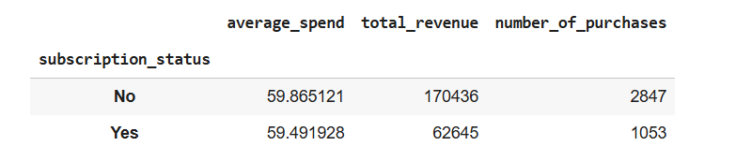
- Discount-Dependent Products – Identified 5 products with the highest percentage of discounted purchases.
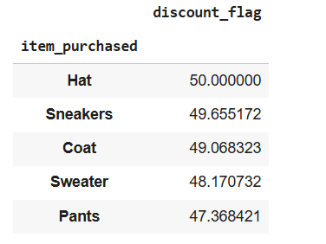
- Customer Segmentation – Classified customers into New, Returning, and Loyal segments based on purchase history.
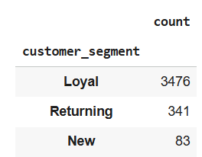
- Top 3 Products per Category – Listed the most purchased products within each category.
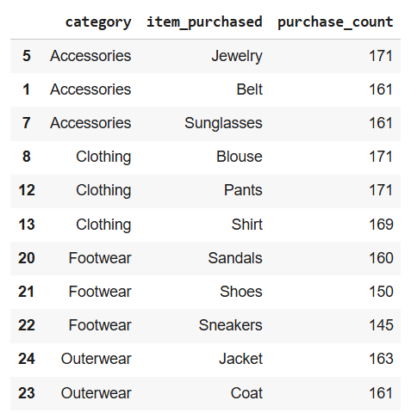
- Repeat Buyers & Subscriptions – Checked whether customers with >5 purchases are more likely to subscribe.
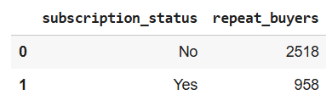
- Revenue contribution analysis across different age groups
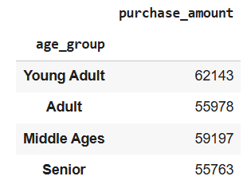
These queries provided actionable insights into customer behavior and product performance.

5. Data Visualization and Dashboard (Power BI)
An interactive dashboard was developed using Power BI to visually communicate insights to non-technical stakeholders.
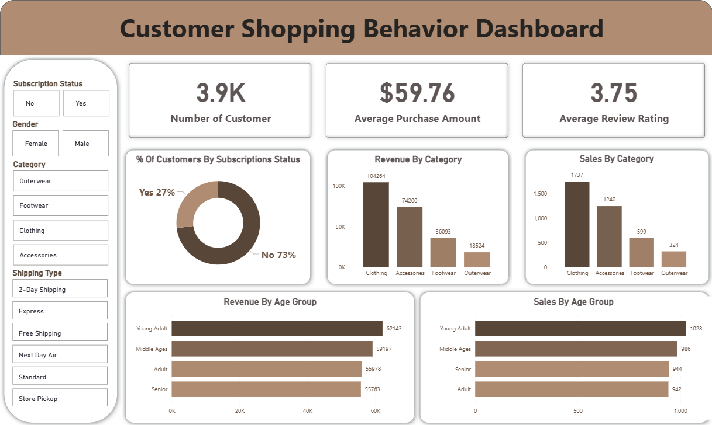

6. Key Insights and Business Recommendations
Based on the analysis, the following recommendations were identified:
- Increase Subscription Adoption: Offer exclusive incentives to convert frequent buyers into subscribers
- Strengthen Customer Loyalty: Introduce reward programs for repeat customers
- Optimize Discount Strategy: Monitor discount usage to protect profit margins
- Promote High-Performing Products: Highlight top-rated and high-demand items in marketing campaigns
- Targeted Marketing Efforts: Focus promotions on high-revenue age groups and preferred shipping users

7. Conclusion
This project demonstrates how customer shopping data can be transformed into meaningful business insights using Python, SQL, and Power BI. By combining data cleaning, analytical queries, and visualization, organizations can better understand customer behavior and design data-driven strategies to improve overall performance.

8. Tools and Technologies Used
- Python (Pandas, NumPy)
- PostgreSQL
- Power BI
- Google Colab

9. Disclaimer
This project report is an original academic and analytical work created for learning and demonstration purposes. The structure and insights are derived from publicly available datasets and standard data analytics practices.

